
Press Release
Paris, March 2, 2026

Stefan IONESCU is appointed Chief Executive Officer of Sofrecom Services Morocco

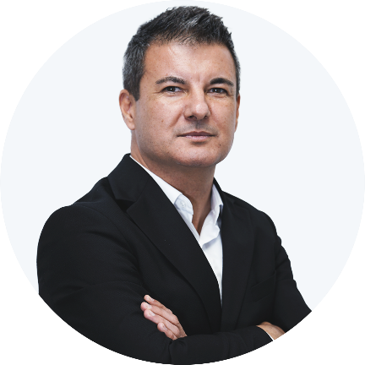
Sofrecom is pleased to announce the appointment of Stefan IONESCU as Chief Executive Officer of Sofrecom Services Morocco, effective February 1, 2026.
Stefan brings extensive international experience within the Orange Group, where he has held several leadership positions, notably as Vice President of Network and Services Shared Operations. In this role, he contributed to major strategic programs focused on transformation, operational excellence, and the development of Group’s telecom and IT services.

Throughout his career, he has led multicultural teams and supported the implementation of high value-added solutions across various Group entities.
In addition to his executive responsibilities, Stefan IONESCU is co-founder and leader of the Leaders in Tech community, dedicated to talent development, knowledge sharing, and the promotion of technology leadership.
A graduate in telecommunications engineering and corporate strategy, Stefan brings to Sofrecom Services Morocco strong expertise in operational excellence, strategic transformation management, and sustainable value creation.
“I am proud to be in Morocco and to collaborate with competent, committed, and inspiring teams. I am convinced that together we can transform our challenges—particularly those related to AI applied to our services and networks—into real levers for creating added value and actively contributing to the development of the digital ecosystem in Morocco. We aim to build, with confidence, the future of our industry by relying on our ability to listen to our clients and on our expertise to deliver solutions and services tailored to their needs,” said Stefan IONESCU.

About Sofrecom
Sofrecom, a subsidiary of the Orange Group, is a consulting, engineering, and services company specialized in the telecommunications sector. Leveraging the diversity of its talents and combining telecom expertise with innovation, Sofrecom supports the technological and environmental transformations of leading industry players.
Founded in 1966 and operating across four continents, Sofrecom has developed strong expertise in Innovation & Digitalization, Information Systems & Networks, Sustainable Development, and Organizations & Business Transformation, across its three core business lines: Consulting, Engineering, and Services. Today, Sofrecom brings together more than 3,000 consultants and engineers from over 25 nationalities, primarily based in France, Morocco, Tunisia, and the United Arab Emirates.
The Group is committed to fostering responsible digital development as a driver of inclusion and respect for the planet.
For more information, visit: www.sofrecom.com
Or follow us on X (formerly Twitter): @sofrecom
And on LinkedIn: linkedin.com/company/Sofrecom

About Sofrecom Morocco
Since 1995, Sofrecom has established itself in Morocco as a key player in information and communication technologies through its software engineering, consulting, and mobile network engineering activities.
With more than 11 nationalities represented, Sofrecom Morocco has built its strength and credibility by leveraging the unique expertise and agility of its employees and relying on multidisciplinary and multicultural skills. Beyond their deep understanding of telecommunications businesses, all Sofrecom Morocco teams share the same passion: creating value for their clients in Morocco and internationally.

About Orange
Orange is one of the world’s leading telecommunications operators, with revenues of €40.3 billion in 2024 and 124,100 employees as of September 30, 2025, including 68,000 in France. The Group served 310 million customers as of September 30, 2025, including 270 million mobile customers and 23 million fixed broadband customers. These figures take into account the deconsolidation of certain activities in Spain related to the creation of the MASORANGE joint venture. The Group operates in 26 countries (including non-consolidated countries).
Orange is also a global leader in telecommunications services for multinational companies under the Orange Business brand. In February 2023, the Group presented its strategic plan “Lead the Future,” built on a new business model driven by responsibility and efficiency. “Lead the Future” leverages network excellence to strengthen Orange’s leadership in service quality.
Orange is listed on Euronext Paris (symbol: ORA).
For more information (web and mobile):
www.orange.com
www.orange-business.com
Follow us on X: @presseorange
Orange and any other Orange product or service mentioned in this press release are trademarks owned by Orange or Orange Brand Services Limited.

Press Contact:
Claire Khoury
Marketing, Communication & CSR Director
claire.khoury@sofrecom.com
Tel: +33 6 80 01 79 34

